**Exp2:**

area_cell=12;

total_area=4200;

total_channels=1001;

radius_cell=sqrt(area_cell/2.59);

n=7 % size of cluster

%b

freq_reuse=12;

min_reusable_distance=(freq_reuse*radius_cell)

%a

area_cluster=(area_cell*n)

total_cluster=(total_area)/(area_cluster)

no_channels_cell=(total_channels)/(n)

total_capacity=(total_channels*total_cluster)

%c

n1=4

area_cluster=(area_cell*n1)

total_cluster1=floor(total_area/area_cluster)

capacity=total_channels*total_cluster1

**Handoff**

clc

clear all

close all

d=0:0.1:50; % Distance of MS from BTS

D=50; % Seperation between BTS1 & BTS2

k1=0;

k2=30;

u1=k1-(k2*log(d)); %Mean

u2=k1-(k2*log(D-d));

Prmin=input('ENTER Minimum value of Received Power in dB(Prmin) : ');

Prho=input('ENTER Absolute value of received power required for Handoff in dB(Prho) : ');

sigma=input('ENTER Standard deviation of shadow fading (sigma) in dB : ');

Pout=qfunc((u1-Prmin)/sigma).*qfunc((u2-Prmin)/sigma); % Probablity of Outage

plot(d,Pout);

xlabel('Distance (meter)');

ylabel('Probability of outage');

title('Probability of outage vs. distance');

Passg1=qfunc((u1-Prho)/sigma).*qfunc((Prmin-u2)/sigma); % Probability of assignment to BTS1

Passg2=qfunc((u2-Prho)/sigma).*qfunc((Prmin-u1)/sigma); % Probability of assignment to BTS2

figure(2)

plot(d,Passg1);

xlabel('Distance (meter)');

ylabel('Probability of assignment');

title('Probability of assignment to a BTS vs. distance.');

hold on;

plot(d,Passg2,'r');

d=[10 13 16 19];

u1=k1-(k2*log(d));

u2=k1-(k2*log(D-d));

sigma=0:30;

for i=1:4

Pout=qfunc((u1(i)-Prmin)./sigma).*qfunc((u2(i)-Prmin)./sigma);

figure(3)

plot(sigma,Pout);

hold on;

end

xlabel('Standard deviation of shadow fading in dB');

ylabel('Probability of outage');

title('Probability of outage vs. standard deviation of shadow fading');

**Adaptive Modulation**

clc

close all

clear all

x=[0 3 5 7 10 12 15 17 20 25 30];

xq=[0 3 5 7 10 12 15 17 20 25 30];

v16=[0.7273 .7273 0.2727 0.1818 0.1818 0.1818 0.0909 0 0 0 0];

v32=[0.9091 0.9091 0.9091 0.8182 0.7273 0.4546 0.3636 0.1818 0 0 0];

v64=[0.9091 0.9091 0.9091 0.7273 0.7273 0.7273 0.5454 0.5454 0.2727 0.09091 0];

v128=[1 1 1 1 1 1 0.8182 0.7273 0.4545 0.2727 0.1818];

vq16=interp1(x,v16,xq,'spline');

vq32=interp1(x,v32,xq,'spline');

vq64=interp1(x,v64,xq,'spline');

vq128=interp1(x,v128,xq,'spline');

figure(1);

plot(xq,vq16,':.',xq,vq32,':.',xq,vq64,':.',xq,vq128,':.')

vf1=zeros(1,11);

vf2=zeros(1,11);

vf3=zeros(1,11);

vf4=zeros(1,11);

thr=0.5;

for xq=1:11

if (vq16(xq)<thr)

vf1(1,xq)=vq16(xq);

end

if (vq16(xq)>thr)

vf1(1,xq)=0;

end

if (vq32(xq)<thr)

vf2(1,xq)=vq32(xq);

end

if (vq32(xq)>thr)

vf2(1,xq)=0;

end

if (vq64(xq)<thr)

vf3(1,xq)=vq64(xq);

end

if (vq64(xq)>thr)

vf3(1,xq)=0;

end

if (vq128(xq)<thr)

vf4(1,xq)=vq128(xq);

end

if (vq128(xq)>thr)

vf4(1,xq)=0;

end

end

for i=1:11

vtemp1(i)=max(vf1(i),vf2(i));

vtemp2(i)=max(vtemp1(i),vf3(i));

vtemp3(i)=max(vtemp2(i),vf4(i));

end

for i=1:11

if vtemp3(i)==0

display('No transmission')

end

if vtemp3(i)==vq16(i)

display('16 QAM')

end

if vtemp3(i)==vq32(i)

display('32 QAM')

end

if vtemp3(i)==vq64(i)

display('64 QAM')

end

if vtemp3(i)==vq128(i)

display('128 QAM')

end

end

figure(2);

plot(x,vtemp3)

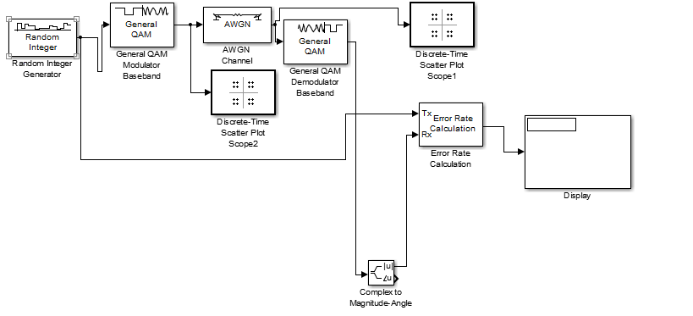

**Rayleigh**

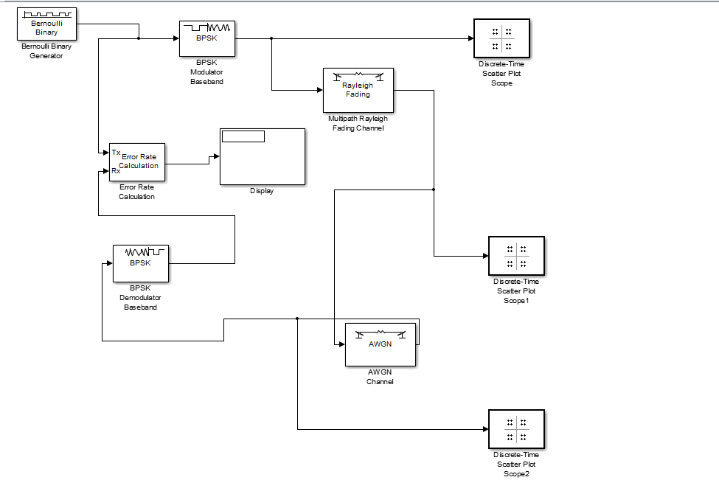

**Rician**

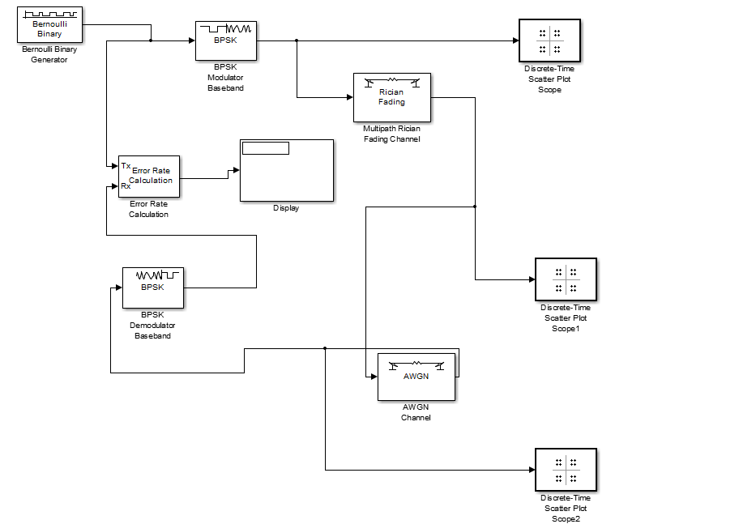

**Walsh Code**

